**Create Transformation**

1. Click **New**, then select **Transformation**. Alternatively you can go to the **File**menu, then select **New**, then Transformation. You can also just press **Ctrl-N**.
2. In the **View** navigator, click **Transformation 1**, then click **Settings**. Or right click the diagram and click Transformation Settings. Or use the **Ctrl+T** shortcut.
3. A window appears where you can specify Transformation properties. In this case, just write a **name** and a **description**, then click Save.
4. Save the Transformation in a specific folder with the name **B13**. This will create a**B13.ktr** file.

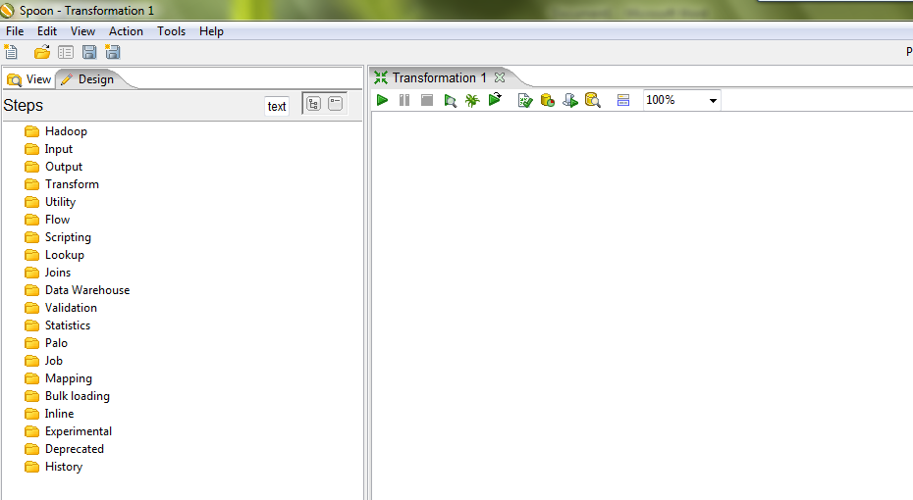

**Constructing the skeleton of the Transformation using Steps and Hops**

A *Step* is the minimal unit inside a Transformation. A wide variety of Steps are available, grouped into categories like Input and Output, among others. Each Step is designed to accomplish a specific function, such as reading a parameter or normalizing a dataset.

A *Hop* is a graphical representation of data flowing between two Steps, with an origin and a destination. The data that flows through that Hop constitutes the *Output Data* of the origin Step, and the *Input Data* of the destination Step. A Hop has only one origin and one destination, but more than one Hop could leave a Step. When that happens, the Output Data can be copied or distributed to every destination. Likewise, more than one Hop can reach a Step. In those instances, the Step has to have the ability to merge the Input from the different Steps in order to create the Output

Here's how to start the Transformation:

To the left of the workspace is the **Steps Palette**. Select the**Input** category.

Drag the **Excel** file onto the workspace on the right.

Select the **Transform** category.

Drag the **Row Normaliser** icon to the workspace.

Drag the **Add Constants** icon to the workspace.

Select the **Output** category.

Drag the **Text file Output** icon to the workspace.

Now you will link the **Excel** file input with the **Row Normaliser** by creating a Hop:

1. Select the first Step.
2. Hold the**Shift** key and drag the icon onto the second Step.
3. Link the **Row Normaliser** with the **Add Constants** via this same process.
4. Link the **Add Constants** with the **Text file Output**.

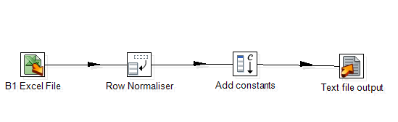

**Configuring the Excel file input Step**

1. Double-click on the **Excel file** input Step.
2. The configuration window belonging to this kind of Step will appear. Here you'll indicate the location, format and content of the input file.
3. Replace the default name with one that is more representative of this Step's function. In this case, type in **Step name** field **B13 Excel File**.
4. In the**Filename** field, type the name and location of the input file or browse the file locally. Press **“Add”**, location of selected filename will be displayed in **Selected files** field.

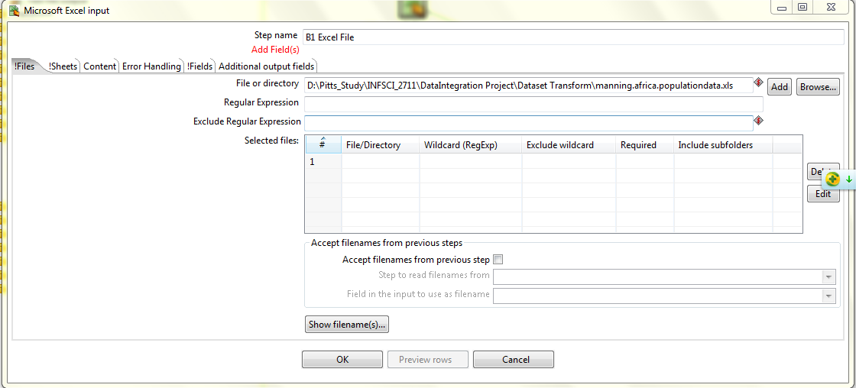

1. Go to **Sheet** page, and when no sheet specified. An **“!”** can be seen before **Sheet.**Click **Get sheetnames** to add **B13** sheet to the grid. Specify the **Start row** of related table in **B13** sheet.



1. Go to **Field** page, and when no sheet specified. An **“!”** can be seen before **Field.** Click **Get fileds from the star row** to add the fields in **B13** sheet to the grid.
2. Replace the second field name “Slave-trade region” with “SlaveTradeRegion”, as space is not database friendly.

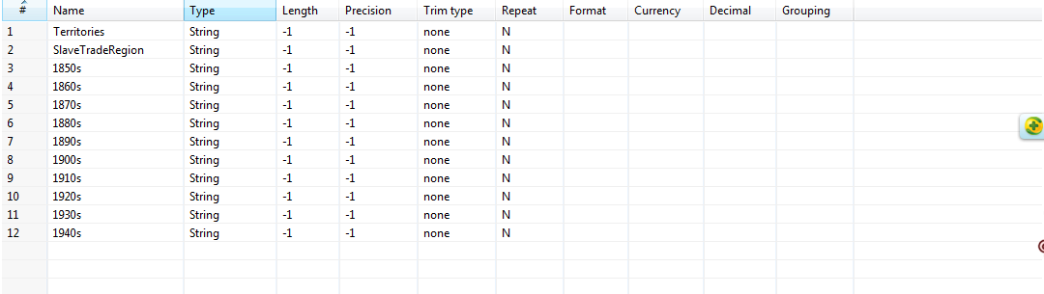

1. Click **OK** to finish defining the Step **Excel file** input.

**Configuring the Row Normaliser Step**

1. Double-click on the **Row Normaliser** Step.
2. The configuration window belonging to this kind of Step will appear.
3. Click **Get fileds** to add field from the previous steps to the grid.
4. Fill in **Value** into the **new field** column for each Fieldname.

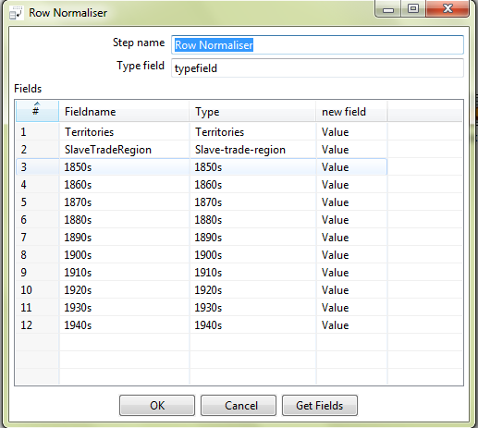

1. Click **OK** to finish defining the Step **Row Normaliser** step.

**Configuring the Add Constant Step**

1. Double-click on the **Add Constant** Step.
2. The configuration window belonging to this kind of Step will appear.
3. Add new Field required in Target Schema. In our case here, fill in the Field as indicated below.

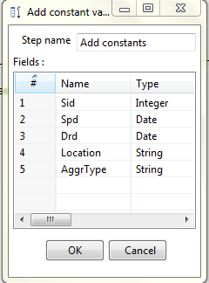

1. Click **OK** to finish defining the Step **Add Constant**.

**Configuring the Text file output Step**

1. Double-click on the **Text file** output Step.
2. The configuration window belonging to this kind of Step will appear.
3. Go to **Fields**, click on **Get Fields** to add fields from the previous steps to the grid.

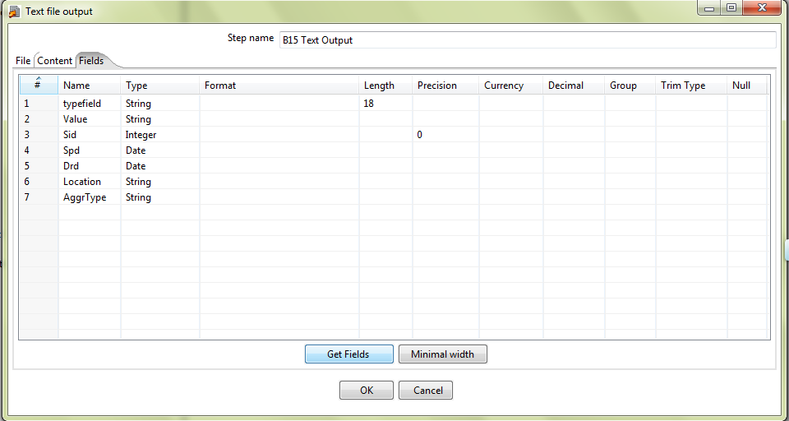

1. Click **OK** to finish defining the Step **Text File output**.
2. Before executing the Transformation, check that everything is properly configured by clicking**Verify**. Spoon will verify that the Transformation is syntactically correct, and look for unreachable Steps and nonexistent connections. If everything is in order (it should be if you followed the instructions), you are ready to preview the output.
3. Click **Run**.
4. Spoon will show a window where you can set, among other information, the parameters for the execution and the logging level. Click **Launch**.

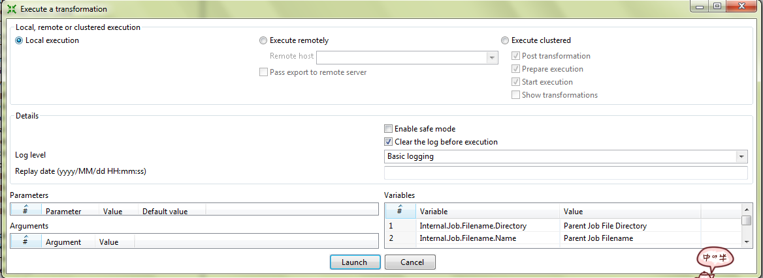

1. A new window tab will appear in the Job window. This is the log tab, which contains a log of the current execution.

